CS3004 Network Computing

Knock, Knock, Who’s There?

Main Objective of the exercise

This is another client-server application. It builds on echoserver and has a more complex protocol based on the well-known series of (very bad) jokes. It is based on the standard Java introduction to distributed systems. The objective is to get it the simple client-server application working on the same machine and then on two different ones. Once you’ve done that the next step is to run a multi-client server version!

What to do – Single Client-Server Knock Knock Application

The following diagram shows the networked application.

As with the echoserver application, KKClient and KKServer are two processes (programs) that interact via the Socket API. You can run them on the same computer or on different computers (as you did in the last tutorial). You can see that the protocol is more extensive. The following shows the architecture.

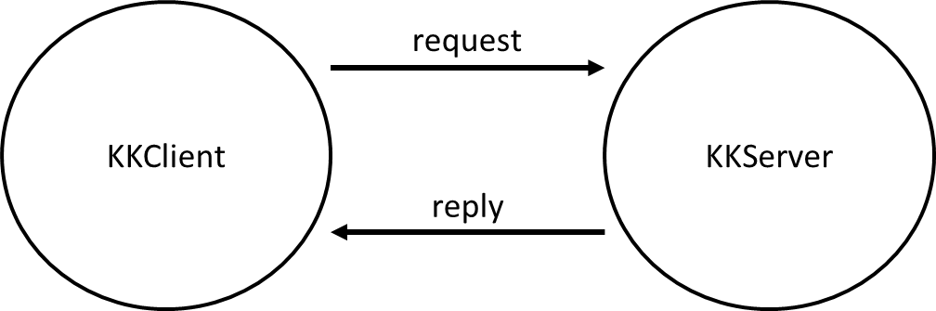
KKClient and KKServer interact by exchanging a series of messages. We can specify these in the following protocol sequence (exchange of messages):

 | KKClient |  | KKServer
 |  |  | [run KKServer]
 | [run KKClient]
 |  |  | [accept KKClient connection]
 | WHILE NOT TERMINATED |  | WHILE NOT TERMINATED
 |  | #S1 | SEND “Knock Knock” TO KKCLIENT
#C3 | RECEIVE “Knock Knock” FROM KKSERVER
#C1 | SEND “Who’s there?” TO KKSERVER
 |  |  | RECEIVE message FROM KKCLIENT
 |  |  | IF message = “Who’s there?” THEN
 |  |  | [Select first part of joke]
 |  |  | SEND First_part_of_joke TO KKCLIENT
 |  |  | ELSE
SEND “You are supposed to say “Who’s there?”” TO
KKCLIENT
 |  |  | ENDIF
 | RECEIVE message FROM KKSERVER
 | IF message = “You are supposed to say “Who’s there?”” THEN
 | GOTO #C1
 | ELSE
 | [message is First_part_of_joke]
#C2 | SEND First_part_of_joke + “who?” TO  KKSERVER
 | ENDIF
 |  |  | RECEIVE message FROM KKCLIENT
 |  |  | IF message = First_part_of_joke + “who?” THEN
 |  |  | [Select answer]
SEND answer + “Would you like another go?” TO
KKCLIENT
 |  |  | ELSE
SEND “You are supposed to say Joke+Who?” TO
KKCLIENT
 |  |  | ENDIF
 | RECEIVE message FROM KKSERVER
 | IF message = “You are supposed to say Joke+“Who?” THEN
 | GOTO #C2
 | ELSE
 | [message is answer + “Would you like another go?”]
 | IF YES THEN
 | SEND “y” TO KKSERVER
 | GOTO #C3
 | ELSE
 | SEND “n” to KKSERVER
 | ENDIF
 | ENDIF
 | [Terminate]
 | ENDWHILE |  | RECEIVE message FROM KKCLIENT
 |  |  | IF message = “y” THEN
 |  |  | GOTO #S1
 |  |  | ENDIF
 |  |  | [message is “n”]
 |  |  | [Terminate]
 |  |  | ENDWHILE

Note that a protocol is just the exchange of messages and their format. […] represents an action that takes place in support of this and is included for clarity. Note also the interaction with the KKClient user is omitted (basically there would be additional PRINTs and READs to tell the user what is going on and to get input from the user). Note also also “Terminate” is used to indicate that the process stops. See the implementation for a suggestion of how you do this.

The algorithms for KKClient and KKServer are…

KKClient

WHILE NOT TERMINATED
#C3 RECEIVE “Knock Knock” FROM KKSERVER
#C1 SEND “Who’s there?” TO KKSERVER
RECEIVE message FROM KKSERVER
IF message = “You are supposed to say “Who’s there?”” THEN
GOTO #C1
ELSE
[message is First_part_of_joke]
#C2 SEND First_part_of_joke + “who?” TO KKSERVER
ENDIF
RECEIVE message FROM KKSERVER
IF message = “You are supposed to say Joke+“Who?” THEN
GOTO #C2
ELSE
[message is answer + “Would you like another go?”]
IF YES THEN
SEND “y” TO KKSERVER
GOTO #C3
ELSE
SEND “n” to KKSERVER
ENDIF
ENDIF
[Terminate]
ENDWHILE

KKServer
[accept KKClient connection]
WHILE NOT TERMINATED
#S1 SEND “Knock Knock” TO KKCLIENT
RECEIVE message FROM KKCLIENT
IF message = “Who’s there?” THEN
[Select first part of joke]
SEND First_part_of_joke TO KKCLIENT
ELSE
SEND “You are supposed to say “Who’s there?”” TO KKCLIENT
ENDIF
RECEIVE message FROM KKCLIENT
IF message = First_part_of_joke + “who?” THEN
[Select answer]
SEND answer + “Would you like another go?” TO KKCLIENT
ELSE
SEND “You are supposed to say Joke+Who?” TO KKCLIENT
ENDIF
RECEIVE message FROM KKCLIENT
IF message = “y” THEN
GOTO #S1
ENDIF
[message is “n”]
[Terminate]
ENDWHILE

The KKClient and KKServer are on BBL. To split the protocol out of the server, KKServer uses KKState. This is essentially one method with a case statement that enables you to change the protocol without needing to change the communication mechanism. Note that you typically only need to change the server class to reflect whether or not the client or the server “speaks” first. Now try getting the code running on the same machine (localhost). Go through the code to try to figure out how it implements the above. When you’ve done this move on to the next bit.

What to do – Multi Client-Server Knock Knock Application

Most network applications have many clients connecting to a server. This next example shows you how to do this for a simple application. This multiple client, single server version that allows a single server to service multiple clients. Note the threading that takes place in the server, i.e. each client is “assigned” its own protocol object. The threading allows the server to concurrently serve multiple clients.

The architecture is as follows:

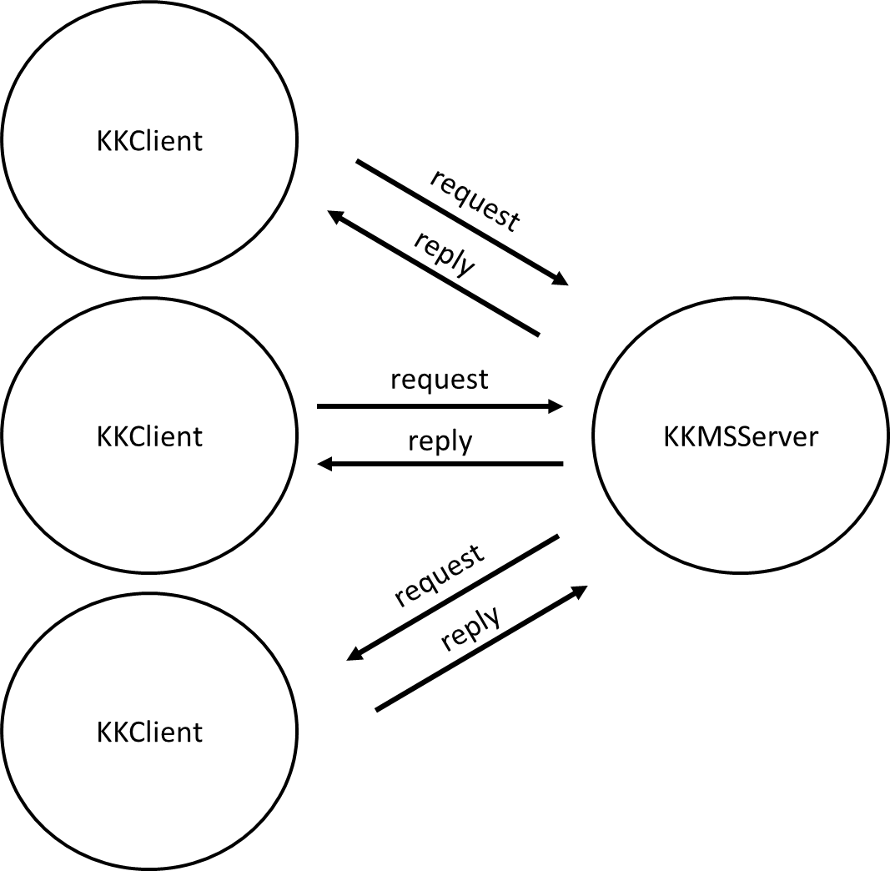
kkmserver implements the multi-threading server. It works as follows:

kkmserver
create a serversocket object and connect it to port 4444
while not terminated
wait for a client to connect
make the connection and start a new thread of execution using kkmsthread
endwhile

kkmsthread
begin
perform the same tasks as the original kkserver
end

Load kkclient, kkmsserver, kkmsthread and kkstate files from blackboard. It is easier to use command windows than Eclipse to run these (i.e. edit and compile them in Eclipse or similar and then run from command windows). First, compile the files. Second try to run one server and three clients.

DON’T FORGET TO RUN THE SERVER FIRST!

Again, when you have got the code up and running try running it with your neighbour (i.e. use their machine name and port number in kkclient). Try two clients on your machine and two on your neighbour’s.

When you have done this, try stepping through each line of your code and discuss with your neighbour what it is doing.

